Step 1: search postman download

postman download for windows

<https://www.google.com/search?q=postman+download+for+windows&rlz=1C1VDKB_enIN1075IN1075&oq=postman+download&gs_lcrp=EgZjaHJvbWUqDAgBEAAYFBiHAhiABDIMCAAQRRg5GLEDGIAEMgwIARAAGBQYhwIYgAQyCggCEAAYsQMYgAQyBwgDEAAYgAQyBwgEEAAYgAQyBwgFEAAYgAQyBwgGEAAYgAQyBwgHEAAYgAQyBwgIEAAYgAQyBwgJEAAYgATSAQg0Mzg3ajBqN6gCALACAA&sourceid=chrome&ie=UTF-8>

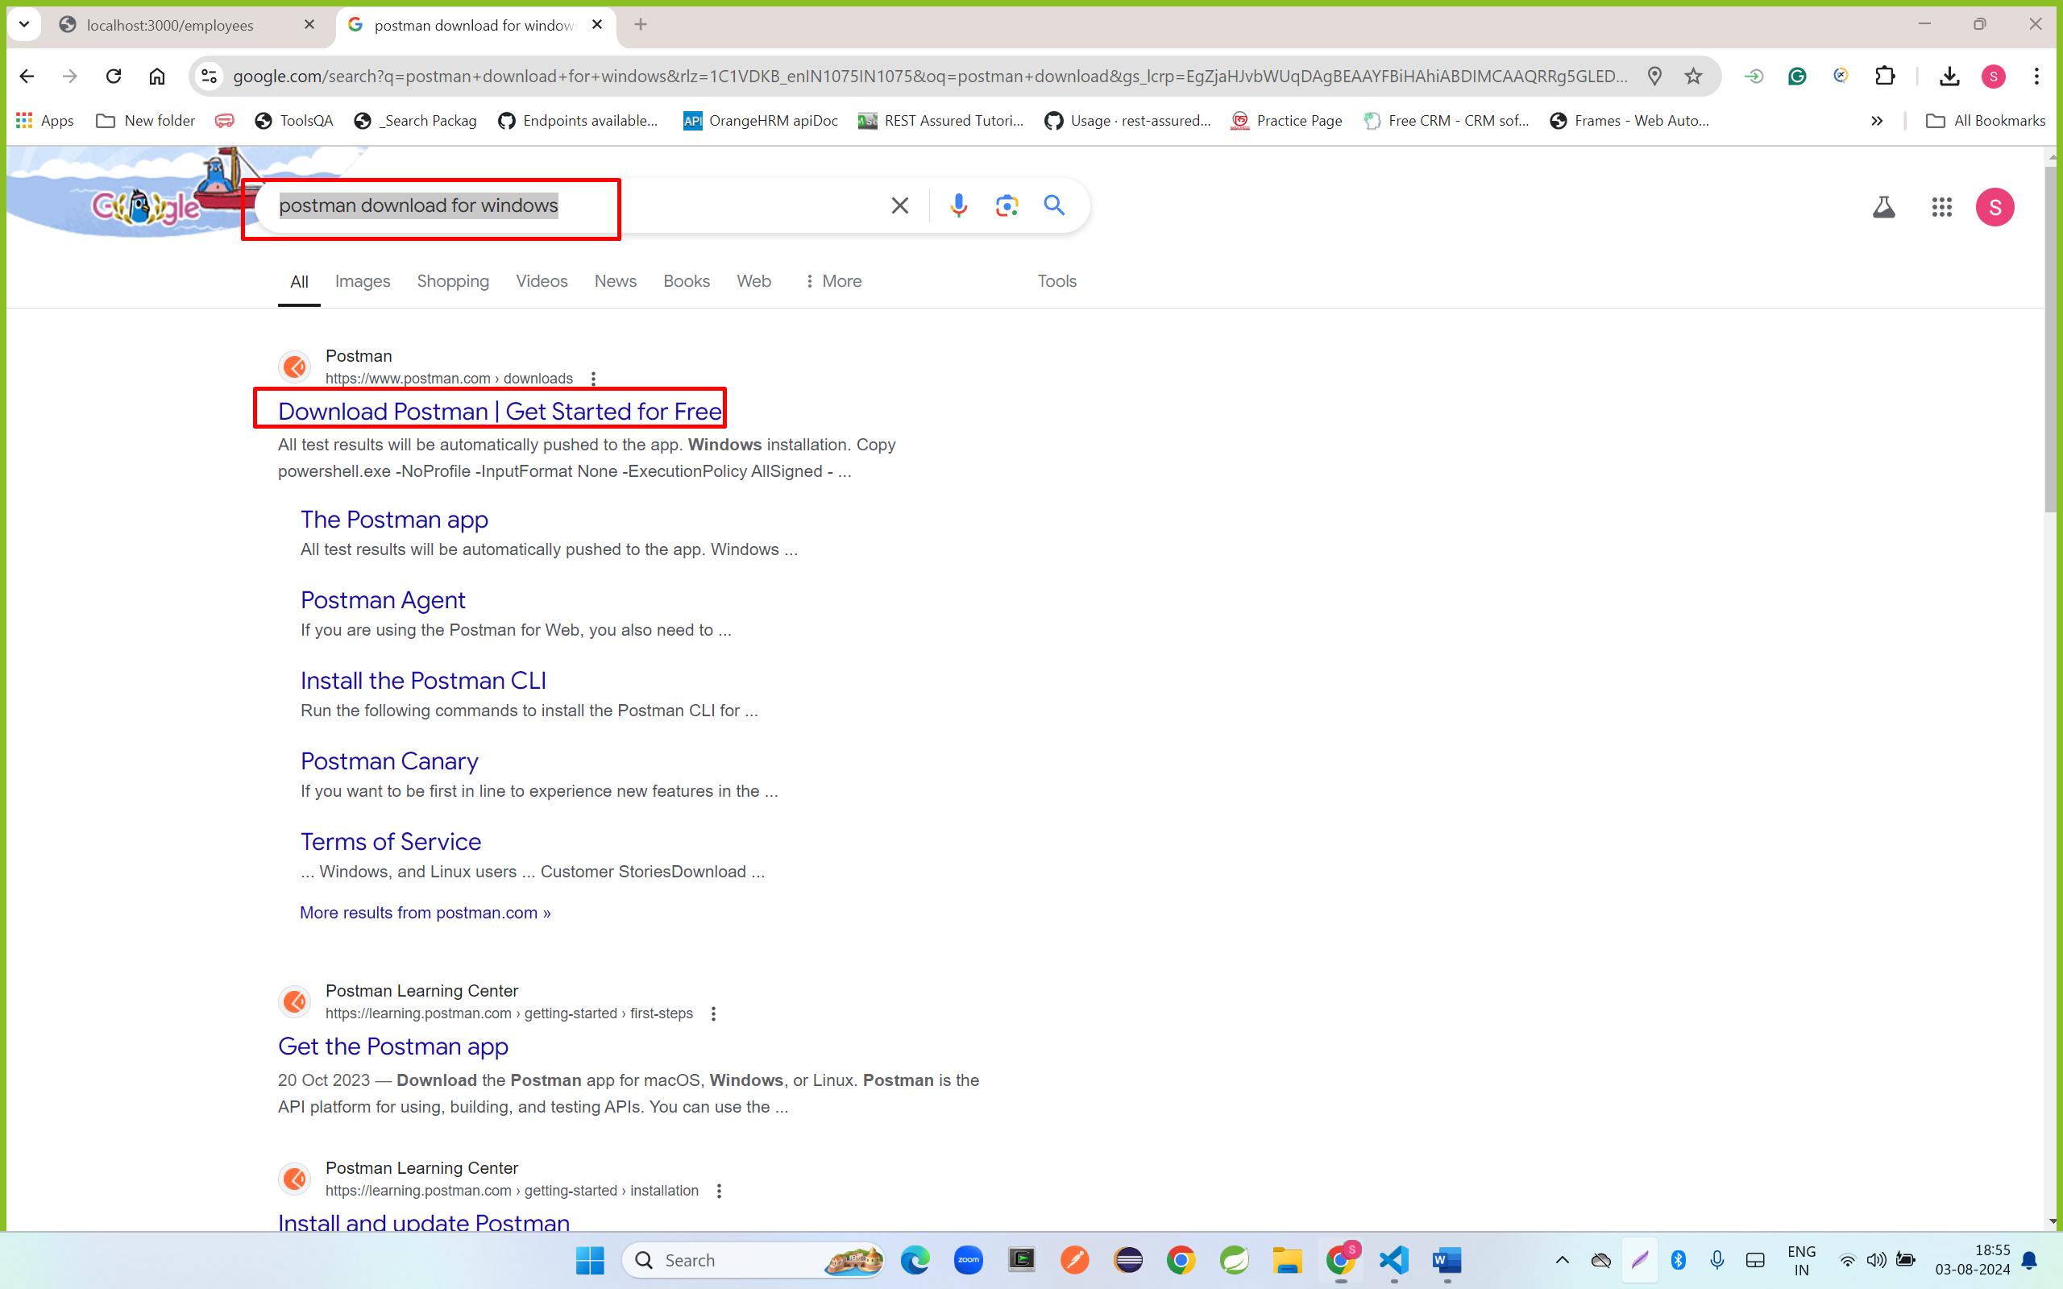

Step 2: click on download button

<https://www.postman.com/downloads/>

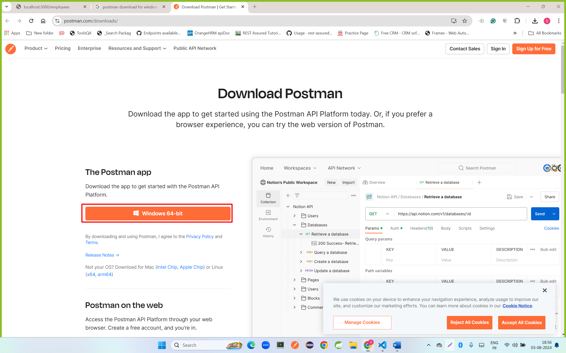

Step 3: double click on downloaded file

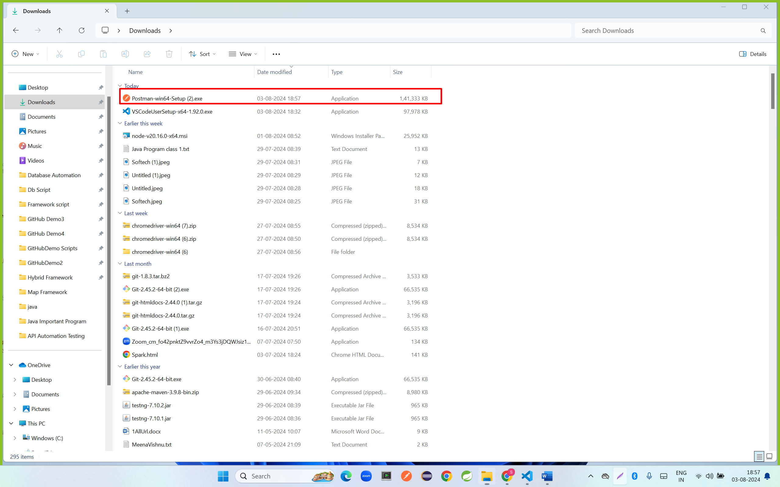

Step 4: click on create account

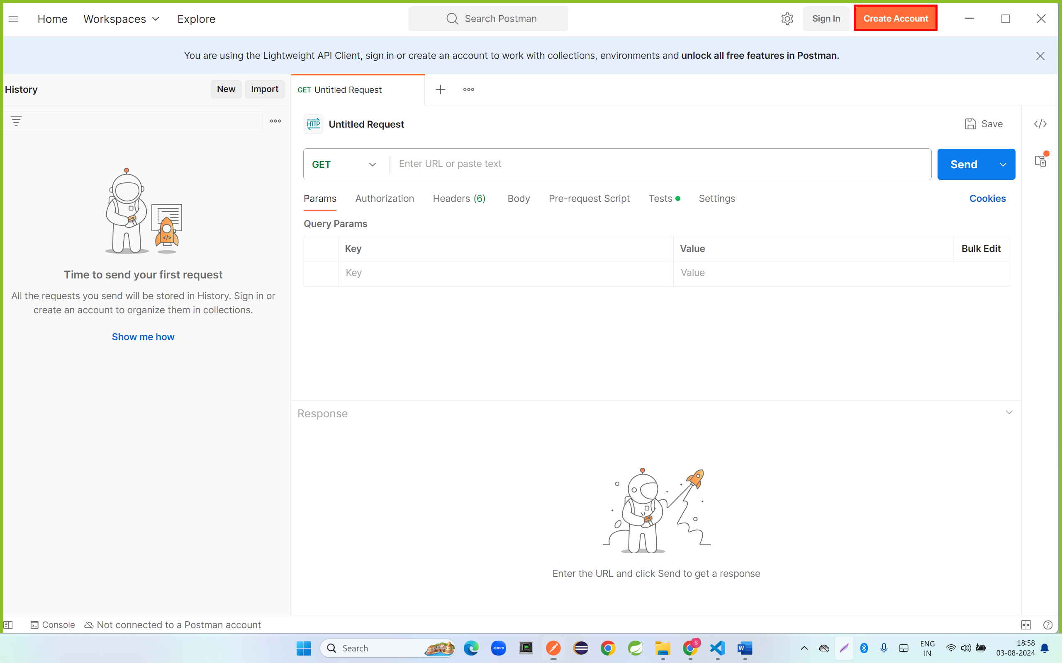

Step 5: enter all information

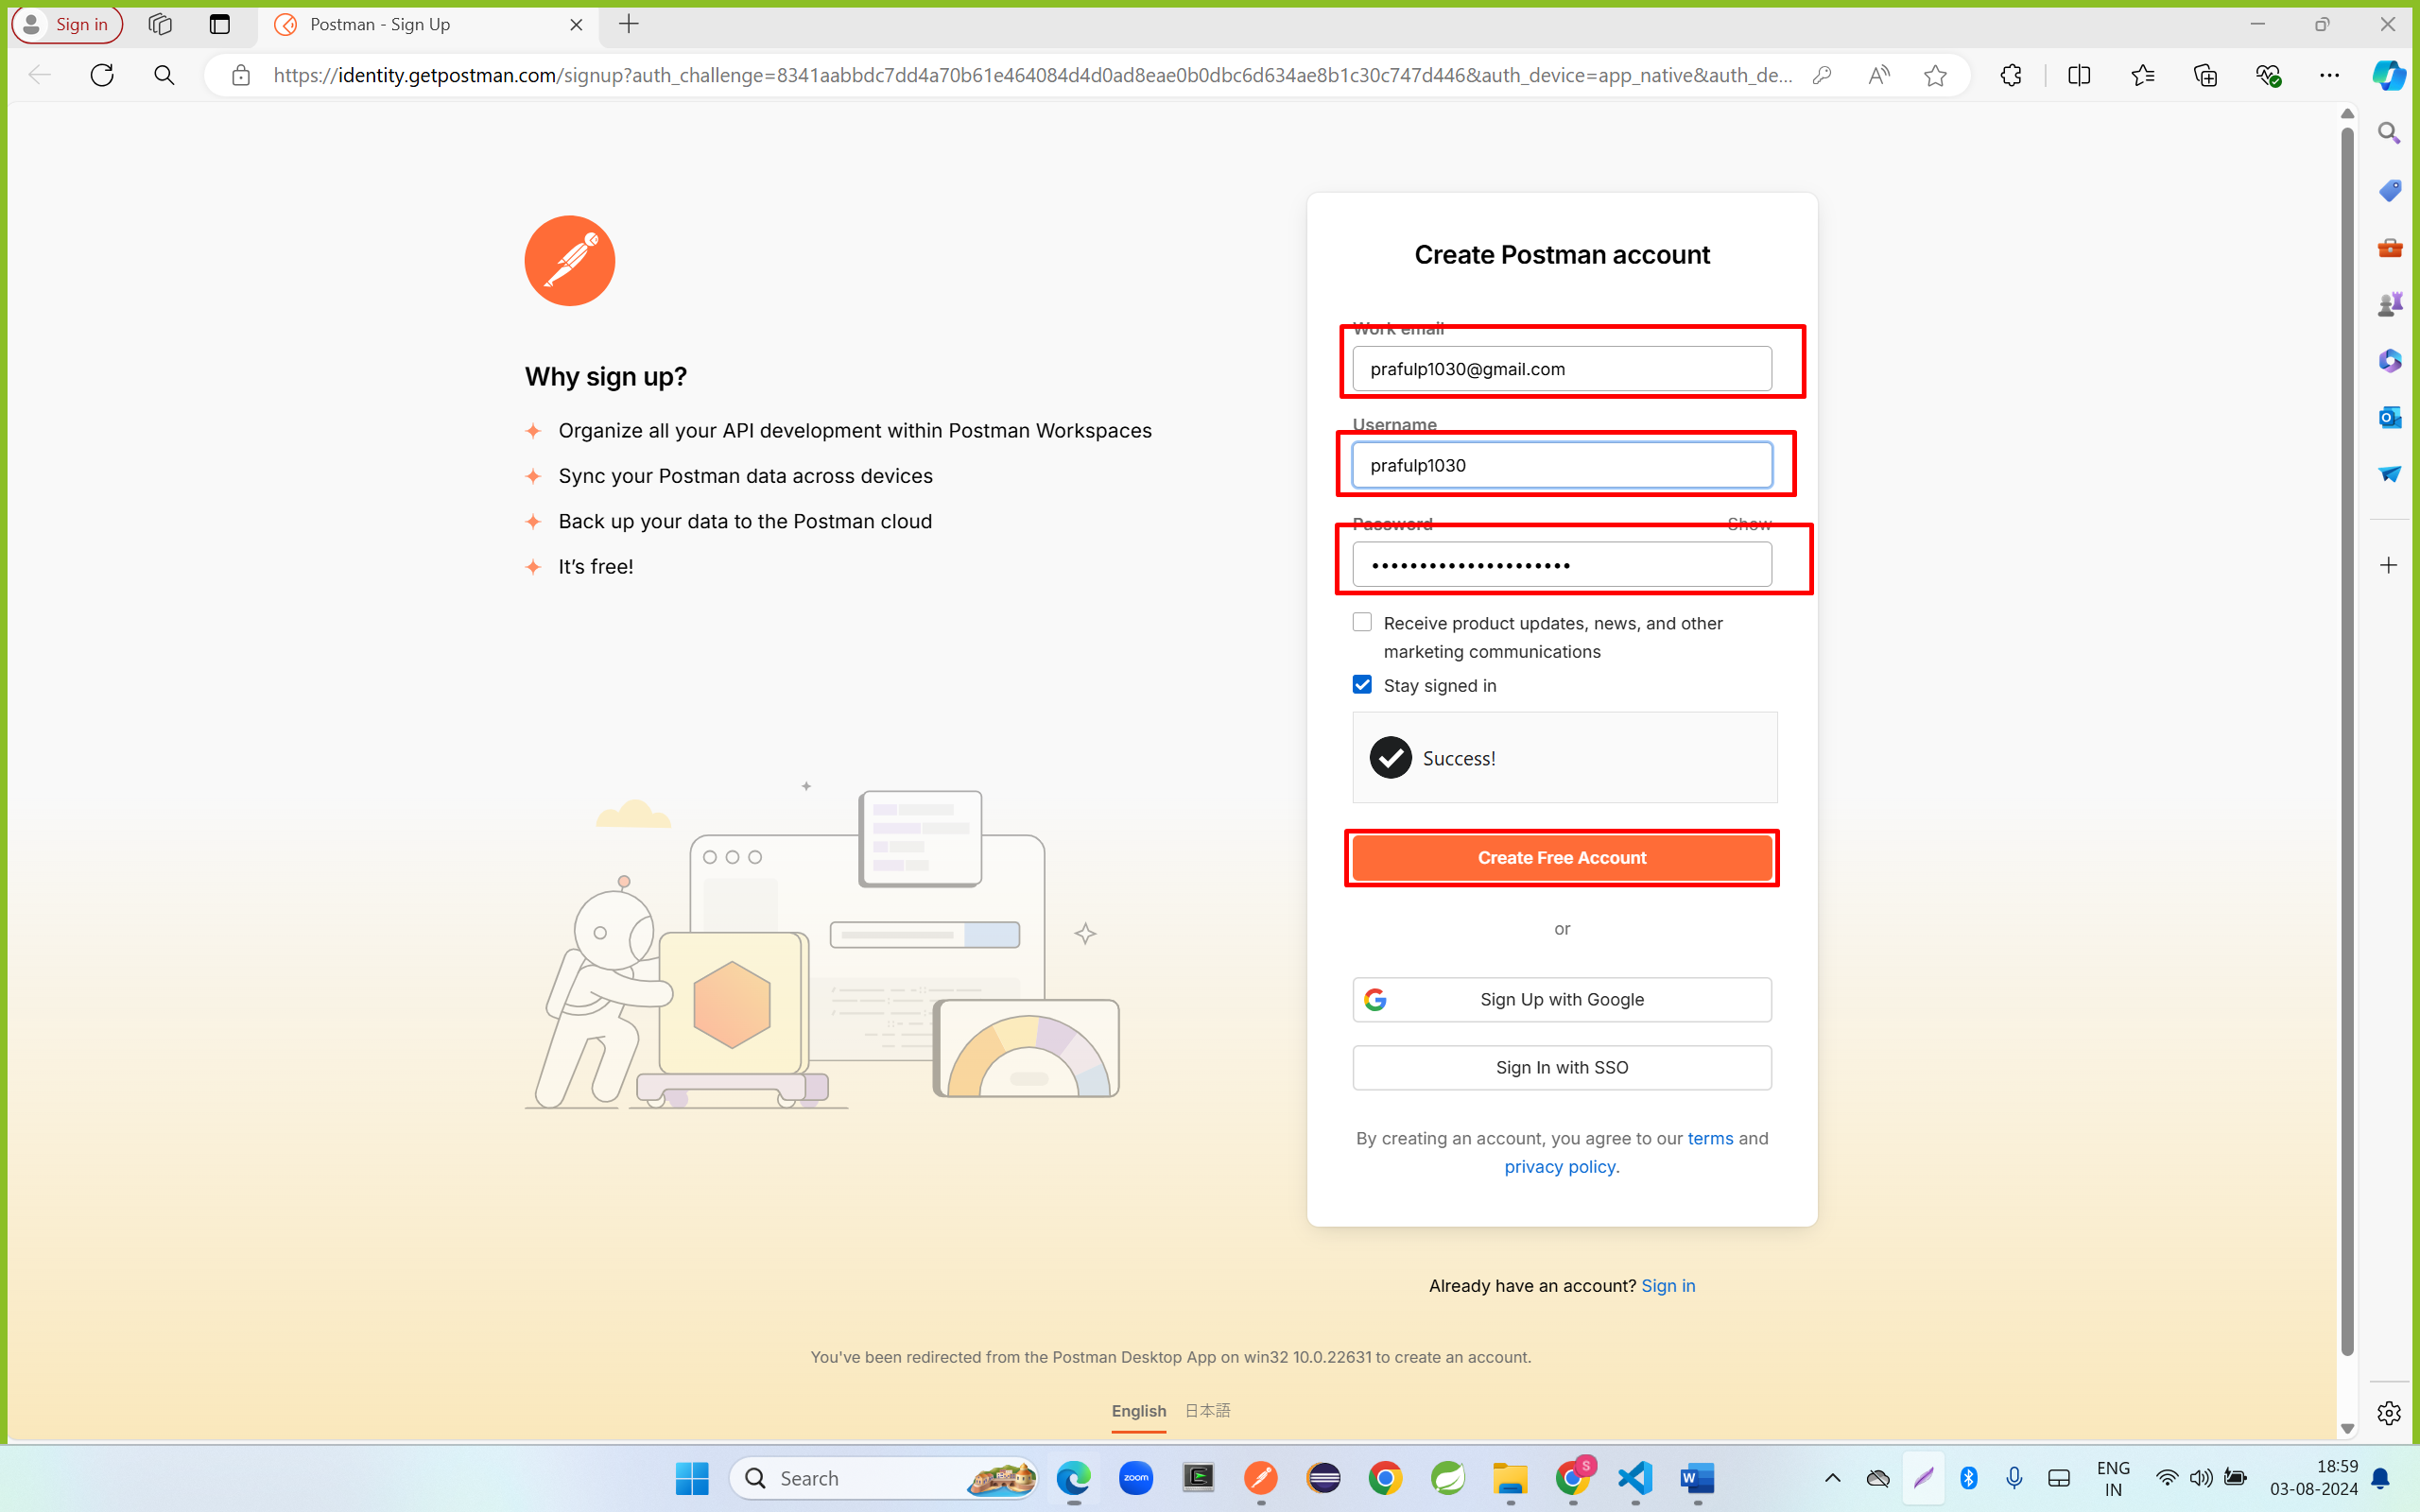

Step 6: enter name, select role and click on next continue

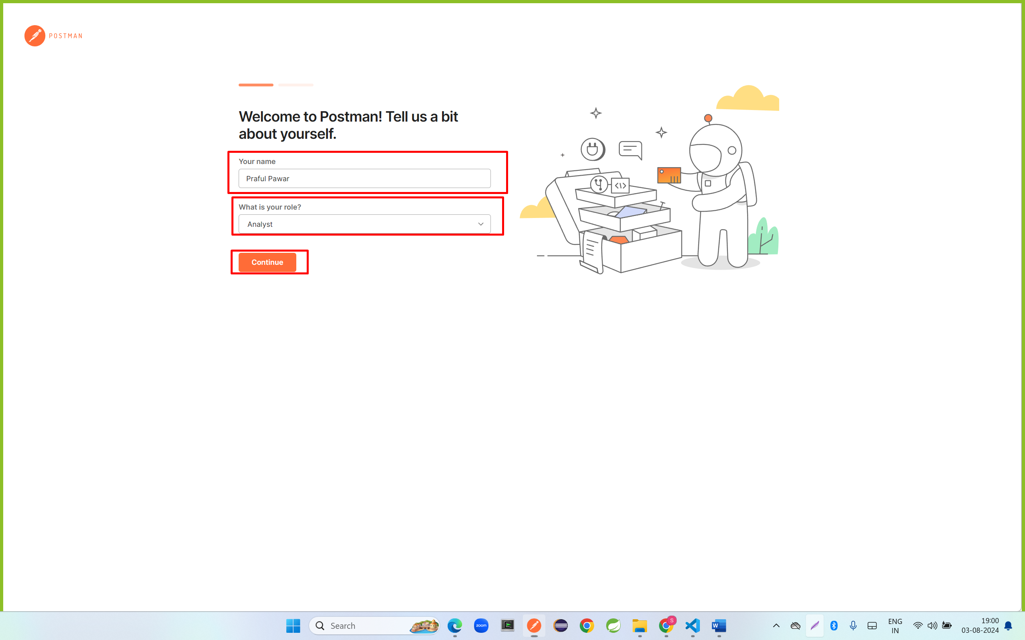

Step 7: click on create collections

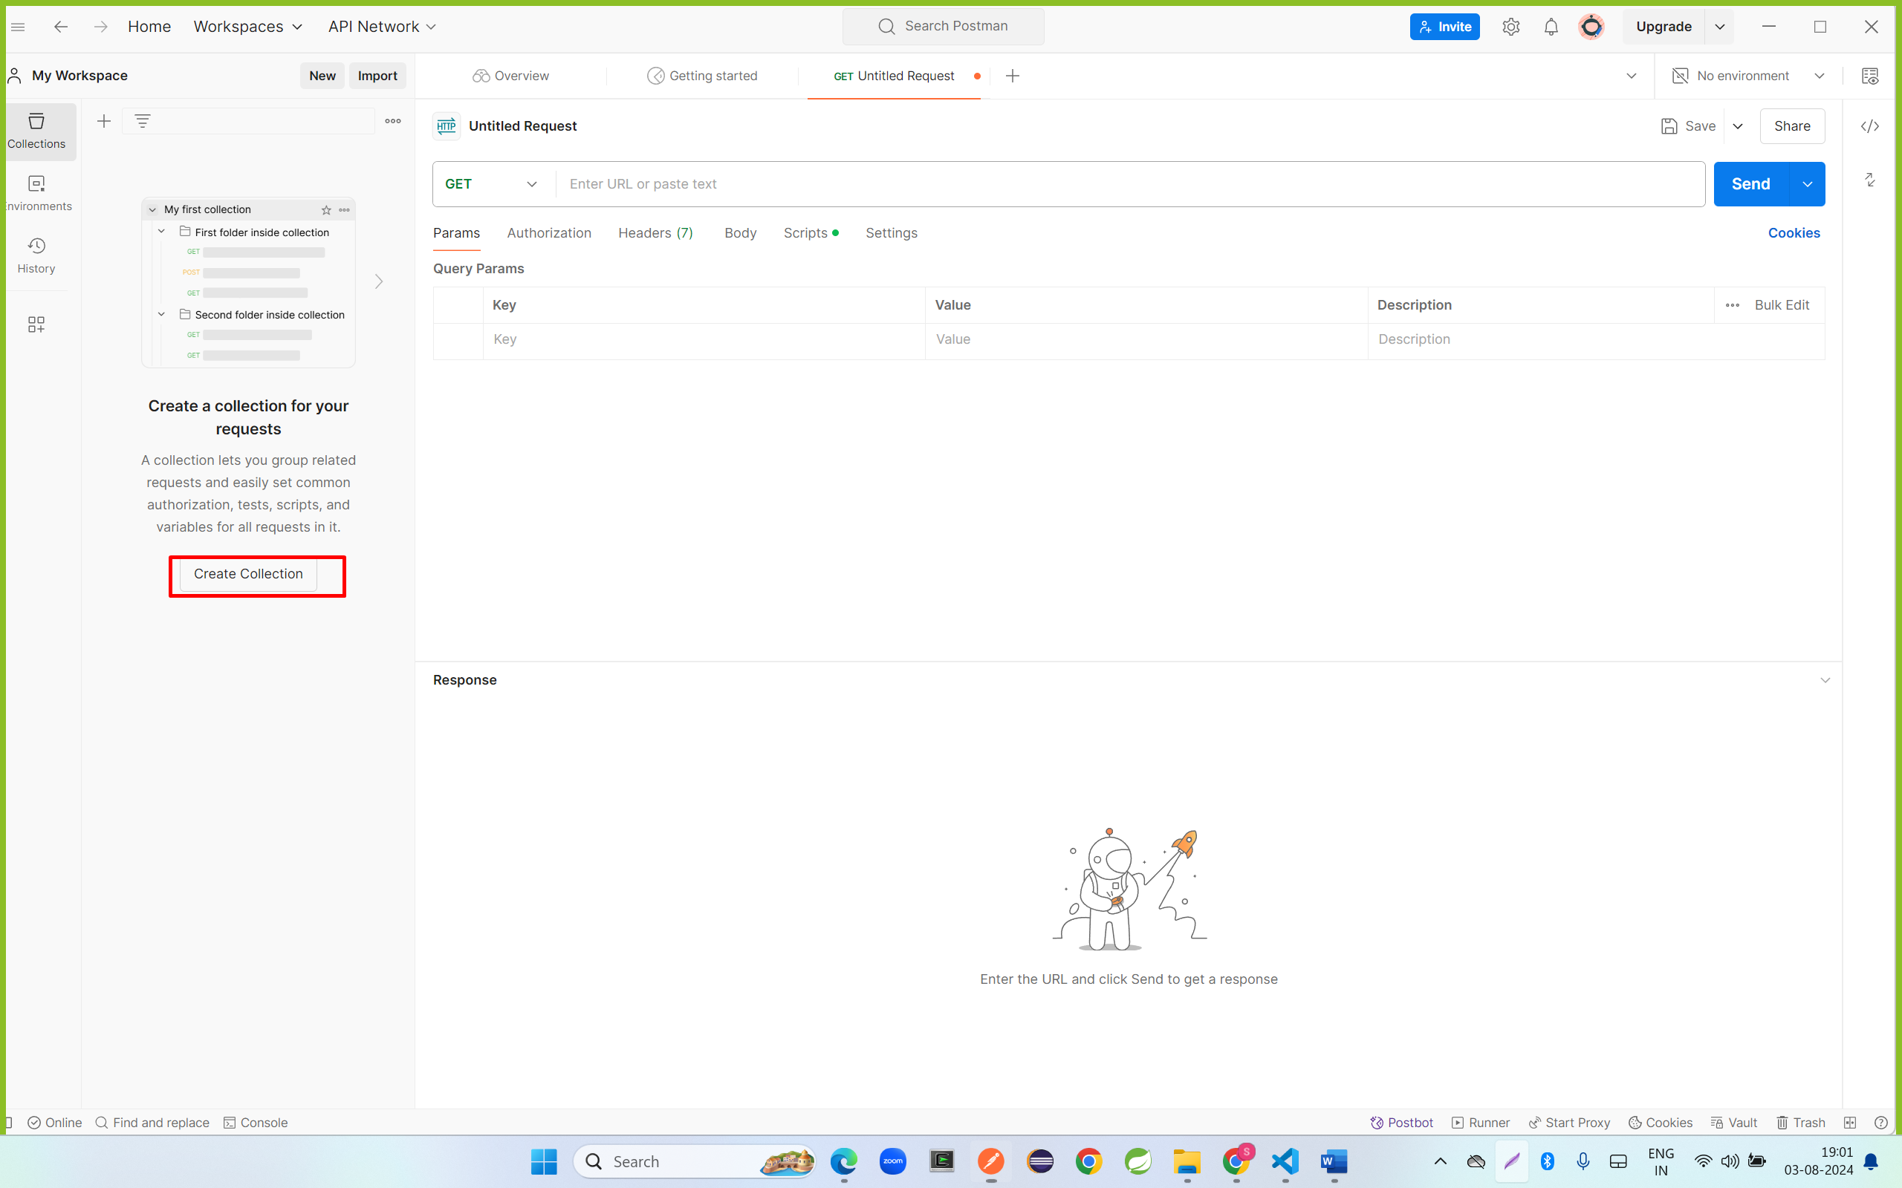

Step 8: click on add request

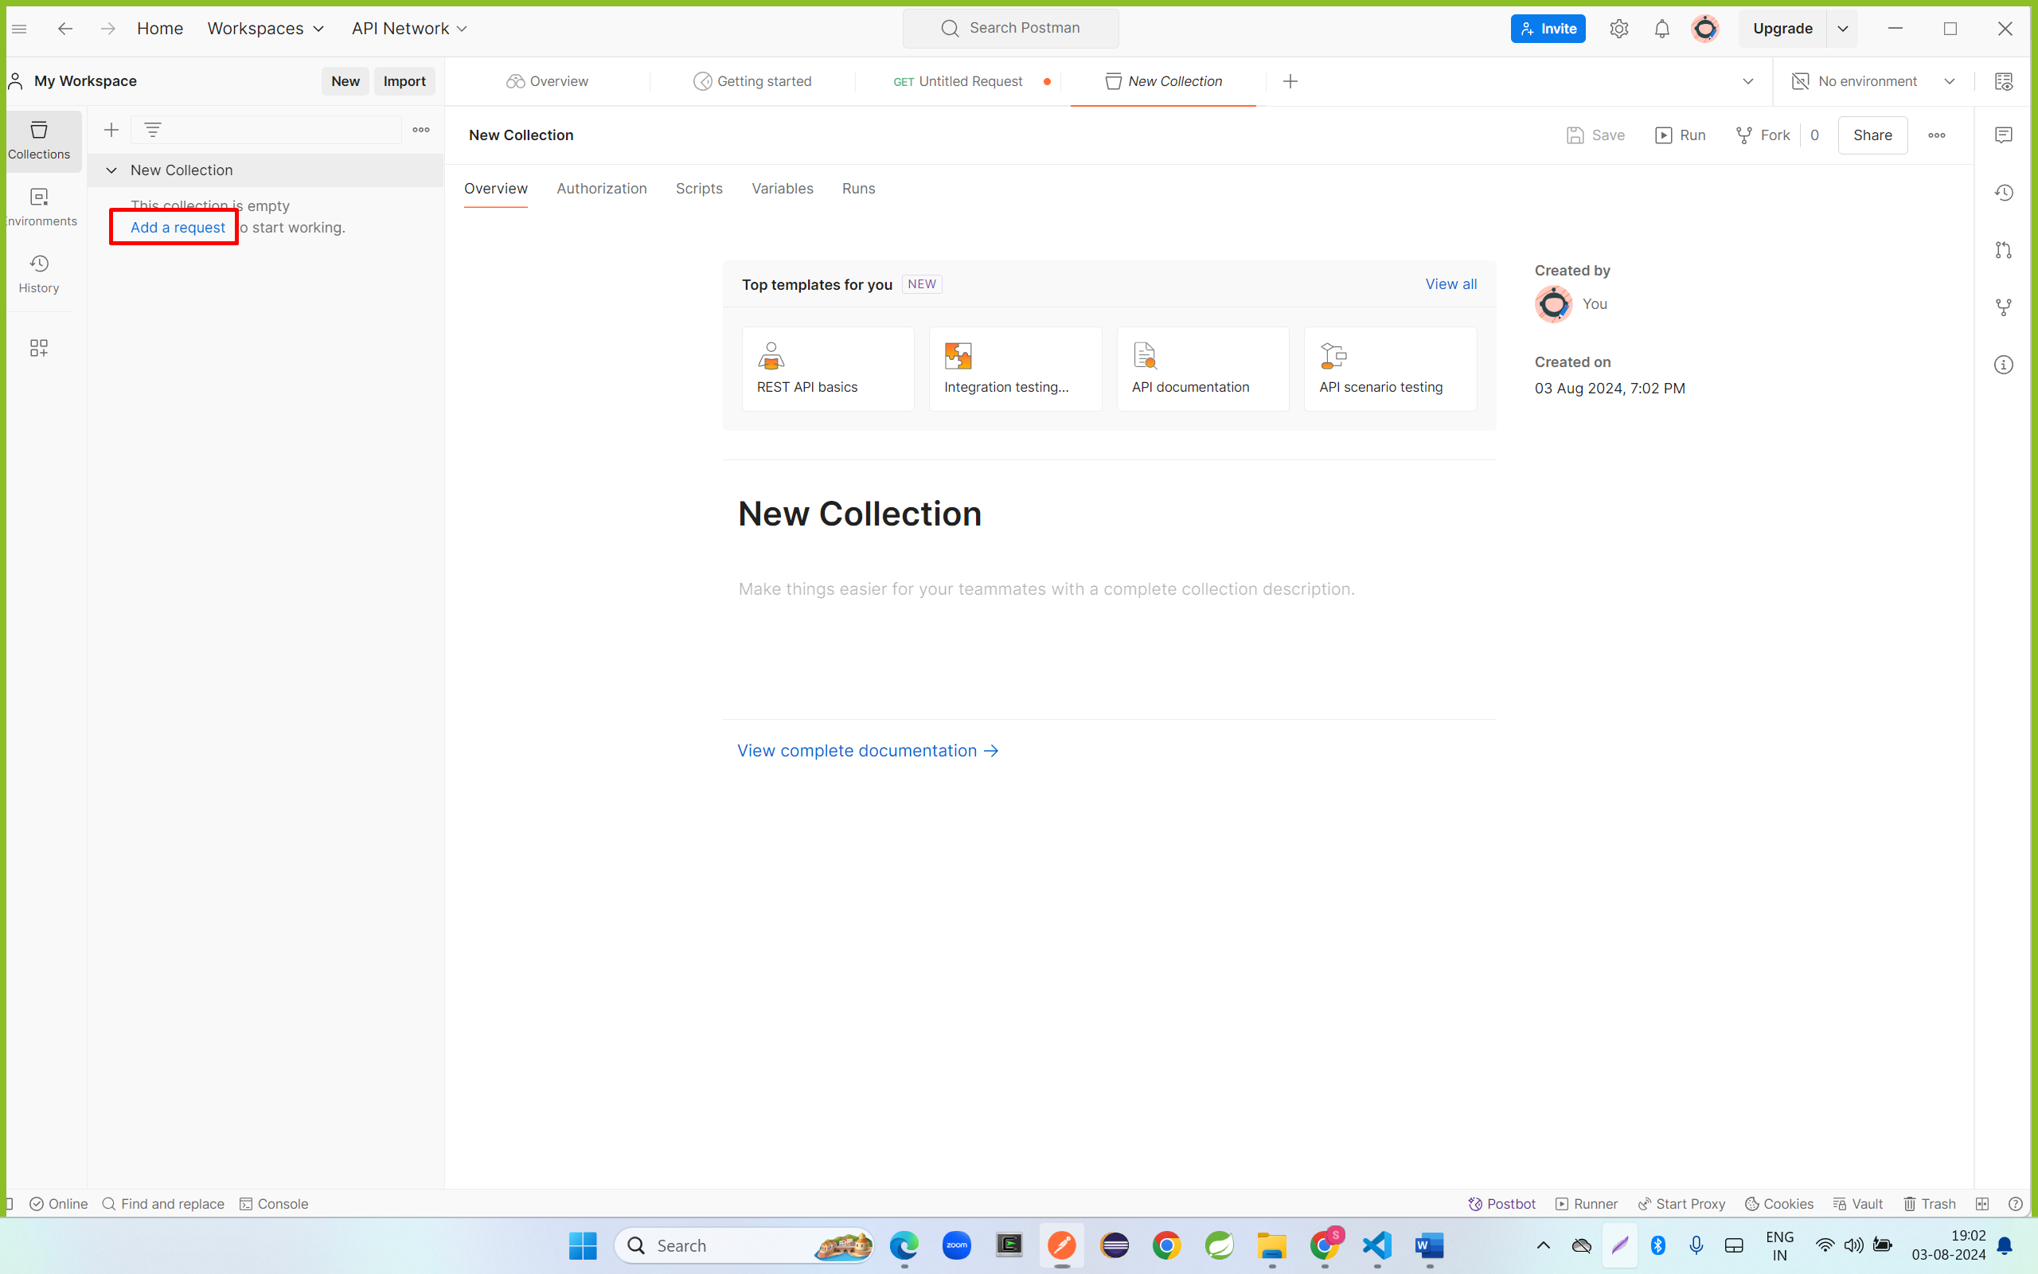

Step 9: enter url and click on send button

